Student Name: Luyang Ye

Student ID: z5280537

Lab2

Since the trace file created by Microsoft Network Monitor does not include the information about SSID, I used my MAC address as the filter to produce the csv files.

The following are the graphs:

Graph 1 indoor total

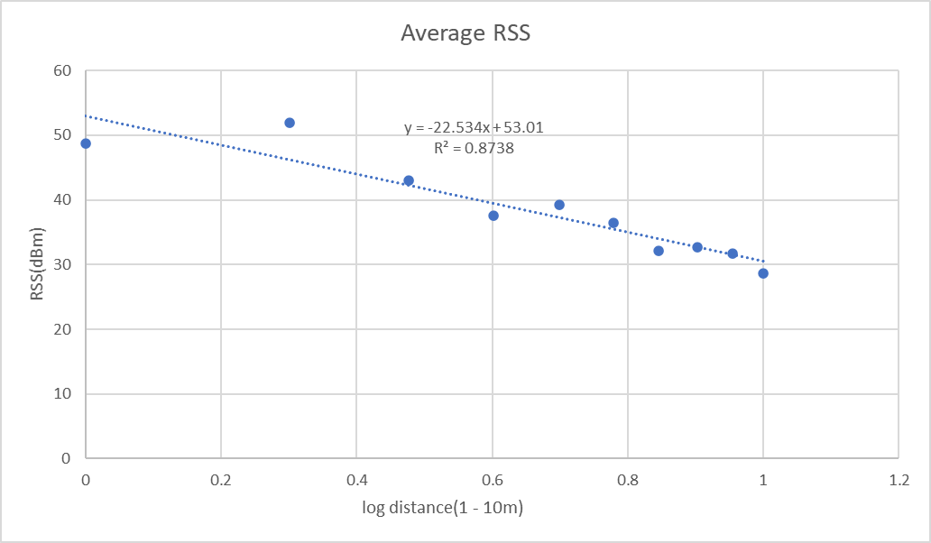

Graph 2. indoor average

Graph 3 outdoor total

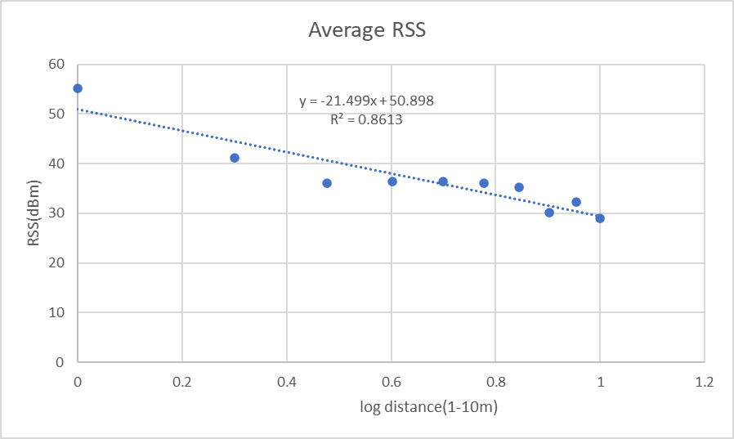

Graph 4. outdoor average

As shown in the above graphs, the slope of the average RSS in indoor environment is -22.535 and the slope of the average RSS in outdoor environment is - 21.499. The difference between them is not large. In my opinion, I think the reason is the environment I chosen. I captured the indoor data in the corridor of my apartment, and captured the outdoor data in the corridor before the library. Since the difference between these two places is not significant, therefore the path loss exponents is not very different.